1)Retrieve all students and their majors
select StudentName,Major from Students;

OUTPUT:
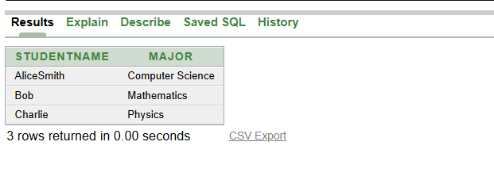

2)List all courses along with the number of credits
select CourseName, Credits from Courses;

OUTPUT:
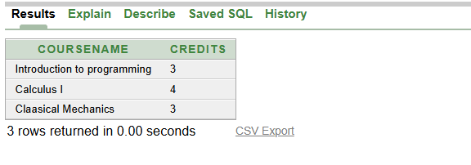

3) Find all students enrolled in a specific course (e.g., 'Introduction to Programming')
select * from students s, courses c, enrollments e
where s.studentID=e.studentID and c.courseID=e.courseID
and c.coursename='Introduction to programming';

OUTPUT:
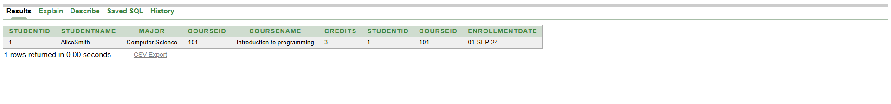

4)Get the list of instructors teaching a specific course(e.g., 'Introduction to Programming')
SELECT i.InstructorName
FROM Instructors i, Courses c, Course_Instructors ci
WHERE i.InstructorID = ci.InstructorID
AND c.CourseID = ci.CourseID
AND c.CourseName = 'Introduction to Programming';
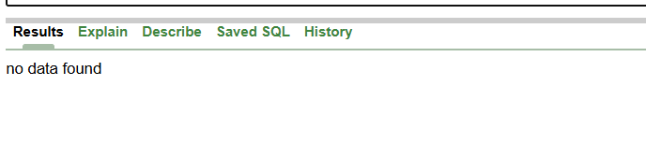

5)Count the number of students enrolled in each course
SELECT c.courseName, COUNT(e.studentID) AS student_count
FROM courses c, enrollments e
WHERE c.courseID = e.courseID
GROUP BY c.courseName;

OUTPUT:
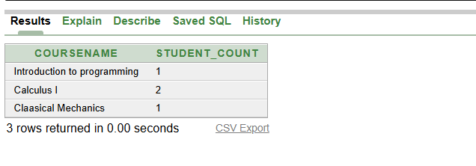

6) List courses along with their instructor names
SELECT c.CourseName, i.InstructorName
FROM Courses c, Instructors i, Course_Instructors ci
WHERE c.CourseID = ci.CourseID
AND i.InstructorID = ci.InstructorID;

OUTPUT:
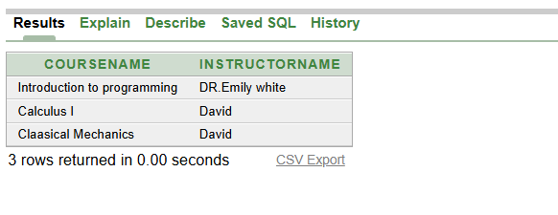

7) Get the number of courses taught by each instructor
SELECT i.InstructorName, COUNT(ci.CourseID) AS Course_Count
FROM Instructors i, Course_Instructors ci
WHERE i.InstructorID = ci.InstructorID
GROUP BY i.InstructorName;

OUTPUT:
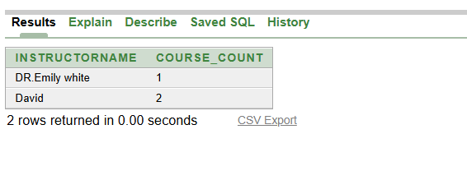

8) Find students enrolled after a certain date (e.g., '2024-01-01')
SELECT s.StudentName, e.EnrollmentDate
FROM Students s, Enrollments e
WHERE s.StudentID = e.StudentID
AND e.EnrollmentDate > TO_DATE('2024-01-01', 'YYYY-MM-DD');

OUTPUT:
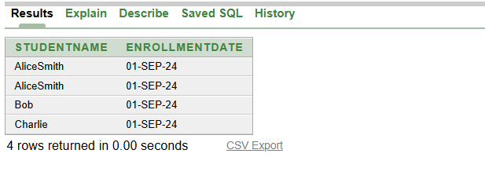

9) Show each student with the total number of credits they are taking
SELECT s.StudentName, SUM(c.Credits) AS Total_Credits
FROM Students s, Courses c, Enrollments e
WHERE s.StudentID = e.StudentID
AND c.CourseID = e.CourseID
GROUP BY s.StudentName;

OUTPUT:
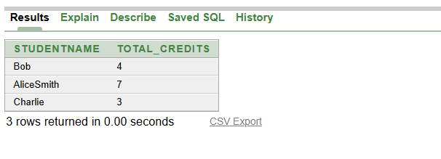

10) Show courses that have more than 3 credits.
SELECT c.CourseName, c.Credits
FROM Courses c
WHERE c.Credits > 3;

OUTPUT:
